Route notes for ride to/from Carlton from Babraham Road P&R

Follow yellow line and arrows on maps.

Map 1. Leave P&R by car exit, turn L . At crossroads R towards Fulbourn.
At top of hill turn R onto Roman Road (RR).

Follow RR, cross A11 bridge at Worsted Lodge & on to 1. Between 1 and 2 RR is more bumpy. If you wish you can take road to Balsham at 1* or 2 (B1052)*. If on RR continue beyond B1052 for ca. 0.5 mile and turn L onto Icknield Way (IW)/Harcamlow Way towards Balsham. Enter Balsham on Woodhall Lane.

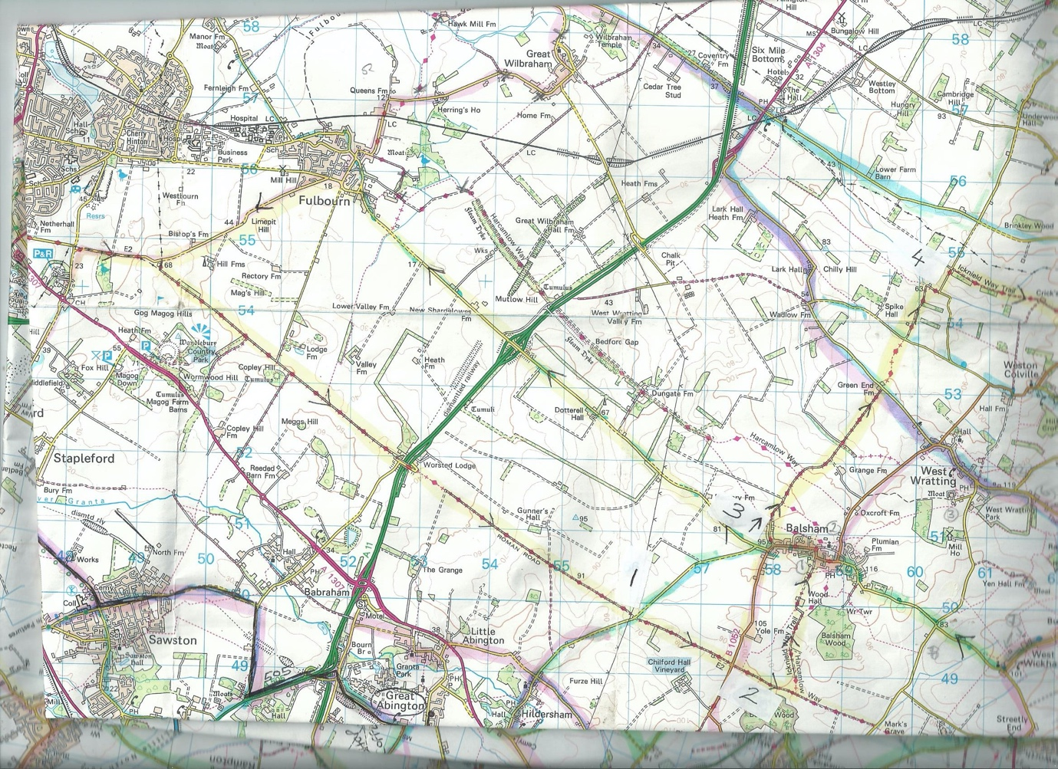

Map 1.

Map 2.

In Balsham turn left on High Street, go to bottom of hill and turn R into Fox Road at 3. (Meet up with *road users at Fox road).

Continue past end of Fox Road along off road track, still the IW, cross road at Green End Farm and continue along IW. It gets bumpy by the R turn at zig-zag at 4, take extra care.
At 4 turn L on minor road and at top of hill turn R onto track, still the IW, towards Willingham Green.

Continue along main track, bit bumpy in places, to road. Turn L on road towards Willingham Green and after about 0.5 mile turn R along track to Carlton. At 5 there is a bridge over ditch, turn left here to Carlton.

Picnic stop by Church at Carlton.

Return by road, follow arrows to Carlton Green, Burton End, West Wickham, Balsham,
(back on Map 1) Fulbourn and P&R by usual choice of routes from Fulbourn. Distance 32 miles.

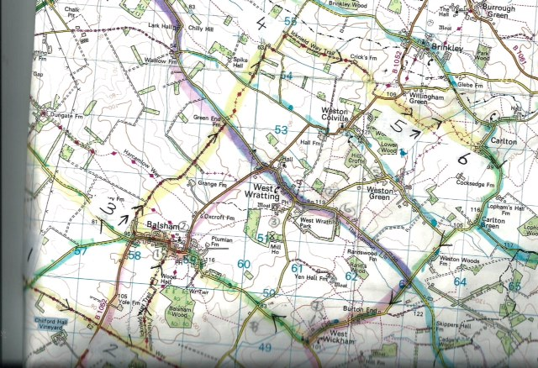

Map 2.

